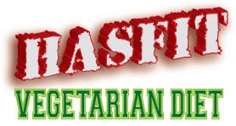

You Have To Eat To Lose Weight!

HASfit’s Vegetarian Diet for Weight Loss was made for you! You need an easy to use system to eat healthy and lose weight, but not feel starved all day. Oh yeah, and you want it for free! We designed this system to be easy for you to integrate into your daily routine and keep it there. By managing your sugar levels, we keep you in the fat burning zone all day! You’ll be eating 5x per day and shopping around the outside of the grocery store buying fresh and unprocessed foods.

Why Do I Have To Eat 5x Per Day?

You may be asking yourself, how can I lose weight if I’m eating 5x per day? Losing weight is all about managing your sugar levels and keeping your metabolism in a fat burning state. If your sugar (or insulin) levels are too high, then your body is storing the extra sugar as fat. If you haven’t eaten in hours, then your sugar levels are low and your body is in starvation or famine mode. A famine is a widespread scarcity of food and your body has learned to conserve energy in times of famine. In this mode, your body isn’t burning fat because your body doesn’t know when your next meal is coming!

Our goal is to keep your sugar levels constant throughout the day. By eating every 2-4 hours and eating foods with low glycemic levels (foods that don’t spike your sugar levels) we are able to keep your metabolism in a fat burning state! If you are used to eating only 1 or 2 meals per day, then this is going to be a major adjustment for your body. It may be difficult to eat frequently over the first week as your body adjusts. After the first week you will notice your body will feel more energized, your mind will feel sharper, and you will be losing fat! Check out this graph that demonstrates how eating frequently will result in consistent sugar levels and more time spent in the fat burning zone.

Stayin’ In The Fat Burnin’ Zone

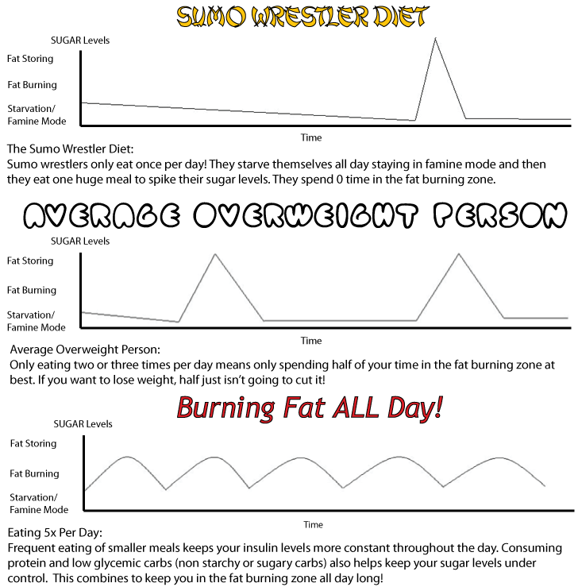

Meal Plan Directions:
There are six meals outlined per day. You are required to eat all 3 main meals (breakfast, lunch, and dinner) and any 2 of the 3 snacks. Each meal outlines your best food choices, but you can eat outside of the choices as long as you eat the correct amount of protein and carbohydrate. It does not require calorie or fat counting, but does require you monitor your protein and carbs. Total grams of protein and carbs are counted for each meal. Choose as many food options as necessary to equal the allotted grams. Green vegetables count as 0 carbs. When calculating your carbohydrate count, subtract your meal’s total dietary fiber count from the total carbohydrates to determine your impact carbs (see example below). Your proteins and carbs choices all count towards the total number.

Snack Meal Example: ½ cup tempeh (15g protein / 8 carbs / 0g fiber) + ½ cup sunflower seeds (6g protein / 8g carbs / 4g fiber) + 2 cups spinach (2g protein / 2g carbs / 2g fiber) = 23g protein / 18g carbs - 6g fiber = 12 impact carbs
Meal 1: Breakfast Protein 10-15 grams:
Best Choices: Eggs, milk, cheese, Greek yogurt, vegan yogurt, soy, nuts, seeds, protein powder or bar

Carbohydrates 30-40 grams:
Best Choices: Oats, whole grain bread, or fruit

Meal 2: Snack Protein 10-20 grams: Best Choices: Greek yogurt, cheese, cottage cheese, protein powder or bar, vegan yogurt, soy, nuts, seeds, beans, or legumes.

Carbohydrates < 10 grams: Only the carbs that come with your protein choice, no additional carb choice.

Meal 3: Lunch Protein 15-25 grams: Best Choices: Cottage cheese, cheese, tempeh, seitan, beans, legumes, seeds, or nuts

Carbohydrates 20-30 grams: Best Choices: Fibrous and green vegetables, quinoa, whole grain bread, brown rice, barley

Meal 4: Snack Protein 10-20 grams: Best Choices: Greek yogurt, cheese, cottage cheese, protein powder or bar, vegan yogurt, soy, nuts, seeds, beans, or legumes.

Carbohydrates < 10 grams: Only the carbs that come with your protein choice, no additional carb choice.

Meal 5: Dinner Protein 20-40 grams: Best Choices: Cottage cheese, cheese, tempeh, seitan, beans, legumes, seeds, or nuts

Carbohydrates: Best Choices: Fibrous and green vegetables, quinoa, whole grain bread, brown rice, barley
15 grams on non workout days
25-35 grams on workout days

Meal 6: Snack Protein 10-20 grams: Best Choices: Greek yogurt, cheese, cottage cheese, protein powder or bar, vegan yogurt, soy, nuts, seeds, beans, or legumes.

Carbohydrates < 10 grams: Only the carbs that come with your protein choice, no additional carb choice.

Favorites:
- Fibrous and green vegetables: spinach, kale, watercress, collard greens, turnip greens, asparagus, brussels sprouts, broccoli, cauliflower, green peas, spirulina, and artichoke
- Beans and legumes: soy, split-pea, fava, lentils, red kidney, black beans, navy, haricot, black-eyed peas, garbanzos, pinta, and limas
- Nuts: walnuts, almonds, pistachios, hazelnuts, pine nuts, cashews and Brazil
- Seeds: sunflower, pumpkin, quinoa, sesame, hemp, and flax

Keys To Success:

- Print the Meal Plan page and put it on your refrigerator.
- Read the entire plan and refer back to it often!
- Stay away from all things white; white bread, white rice, pasta, potatoes, beer, and sugar.
- Plan your meals ahead of time.
If you are on-the-go, then make your meals ahead of time and bring them with you. Buy easy snacks like nuts and protein bars that you can take with you wherever you go. Not having time cannot be an excuse if you are to be successful. How dedicated are you?
- Protein at every meal!

THE NO LIST
Do not eat the following:

- White starches including: white bread, white rice, white pasta, white potatoes, corn, and sugar.
  - Starches act just like pure sugar when entering the blood stream. You might as well have a 2 liter of soda.
  - Starches spike insulin levels causing the production of fat gain. After the spike, insulin levels plummet, lowering one’s metabolic rate as the body is put into a state of starvation.
- More than one serving on fruit per day.
  - Fruit is to be consumed at breakfast or lunch only.
  - The best fruit choices include apples, honeydew, and berries.
  - The worst fruit choices include bananas, oranges, and tropical fruit
- Beverages with calories
  - No soda.
  - No juices
  - Only unsweetened tea
- Carb + Fat Meals
  - Meals should be based around Protein + Carbs, or Protein + Fat.
  - The worst meals combine Carbs + Fat, e.g. ice cream, pizza, alfredo pasta
  - Protein must be present in each meal.
- Sugary snacks or chocolate.

PSYCHOLOGICAL
YOU vs you

As with all things in life, your level of success depends solely on your level of commitment. If you give 10% percent commitment, then you will get 10% results. If you are disciplined, then you will be extremely successful. You now have the tools and the knowledge, but do you have the willpower and mental strength to achieve your goals? Consider this a test, a personal challenge. YOU vs.you. There is no such thing as an overnight transformation, but consider how long it took you to get to where you’re at now. The gratification you will feel after accomplishing this goal will far surpass any pleasure received from a late night ice cream binge. When you reach the end of this journey, you will be a stronger person for it.

Counting Carbs

Nutrition Facts labels on packaged foods tell you how many carbs are in a particular food. But many healthy, fresh foods don’t come with labels, such as fresh vegetables or fruits. Or you may be eating out and no able to look at the package. Learn the serving sizes of carbohydrate-containing foods that you eat often. Use this chart to look up the serving sizes of many common foods.
Remember:
1 serving of these foods = about 15 grams of carbohydrate

Grains (starches)
Bagel . . . . . . . . . . . . . . . . . . . . . . . . . . . . . . . . . . . . . . . . . . . . . . . . ¼ (1 oz)
Bread (white, whole-wheat, pumpernickel, rye) . . . . . . . . . . . . 1 slice (1 oz)
Crackers (white flour) . . . . . . . . . . . . . . . . . . . . . . . . . . . . . . . . . . .6 crackers
Graham crackers (2½ inches sq) . . . . . . . . . . . . . . . . . . . . . . . . . .3 crackers
Muffin (small) . . . . . . . . . . . . . . . . . . . . . . . . . . . . . . . . . . . . . 1 /5 muffin (1 oz)
Oats (cooked) . . . . . . . . . . . . . . . . . . . . . . . . . . . . . . . . . . . . . . . . . . . . ½ cup
Wheat Pasta . . . . . . . . . . . . . . . .. . . . . . . . . . . . . . . . . . . . . . . . . . . . . 1 /3 cup
Pita bread (6 inch) . . . . . . . . . . . . . . . . . . . . . . . . . . . . . . . . . . . . . . . . ½ pita
Popcorn (low-fat) . . . . . . . . . . . . . . . . . . . . . . . . . . . . . . . . . . . . . . . . .3 cups
Pretzels. . . . . . . . . . . . . . . . . . . . . . . . . . . . . . . . . . . . . . . . . . . . . . . . . . ¾ oz
Rice (white or brown) . . . . . . . . . . . . . . . . . . . . . . . . . . . . . . . . . . . . . . 1 /3 cup
Tortilla (6 inch, corn or flour) . . . . . . . . . . . . . . . . . . . . . . . . . . . . . . .1 tortilla
Tortilla chips . . . . . . . . . . . . . . . . . . . . . . . . . . . . . . . . . . . 9–13 chips (¾ oz)

Starchy Vegetables and Beans
Beans (garbanzo, pinto, kidney, white) and peas . . . . . . . . . . . . . . . . ½ cup
Baked beans. . . . . . . . . . . . . . . . . . . . . . . . . . . . . . . . . . . . ..... . . . …. 1 /3 cup
Corn . . . . . . . . . . . . . . . . . . . . . . . . . . . . . . . . . . . . . . . . . . . . . . . . . . . ½ cup Lentils . . . . . . . . . . . . . . . . . . . . . . . . . . . . . . . . . . . . . . . . . . . . . . . . . . ½ cup
Peas (green) . . . . . . . . . . . . . . . . . . . . . . . . . . . . . . . . . . . . . . . . . . . . ½ cup
Potato (baked, boiled, or mashed. . . . . . . . . . . . . ½ cup or 1 medium (3 oz)
Winter squash. . . . . . . . . . . . . . . . . . . . . . . . . . . . . . . . . . . . . . . . . . . . .1 cup

Fruits
Apple (small, unpeeled) . . . . . . . . . . . . . . . . . . . . . . . . . . . . . . 1 apple (4 oz)
Applesauce (unsweetened) . . . . . . . . . . . . . . . . . . . . . . . . . . . . . . . . . ½ cup
Apple juice . . . . . . . . . . . . . . . . . . . . . . . . . . . . . . . . . . . . . . . . . . . . . . ½ cup
Banana (small) . . . . . . . . . . . . . . . . . . . . . . . . . . . . . . . . . . . 1 banana (4 oz)
Blueberries or blackberries . . . . . . . . . . . . . . . . . . . . . . . . . . . . . . . . . ¾ cup
Cantaloupe (small) . . . . . . . . . . . . . . . . . . . . . . . . . . . . . . . . 1 /3 melon (11 oz)
Fruit cocktail . . . . . . . . . . . . . . . . . . . . . . . . . . . . . . . . . . . . . . . . . . . . . ½ cup
Grapes (small) . . . . . . . . . . . . . . . . . . . . . . . . . . . . . . . . . . . . . . . . . 17 (3 oz)
Orange (small) . . . . . . . . . . . . . . . . . . . . . . . . . . . . . . . . . . 1 orange (6½ oz)
Orange juice . . . . . . . . . . . . . . . . . . . . . . . . . . . . . . . . . . . . . . . . . . . . . ½ cup
Peach . . . . . . . . . . . . . . . . . . . . . . . . . . . . . . . . . . . . . . . . . . 1 medium (6 oz)
Peaches (canned in syrup or juice) . . . . . . . . . . . . . . . . . . . . . . . . . . . ½ cup
Pear (large). . . . . . . . . . . . . . . . . . . . . . . . . . . . . . . . . . . . . . . . . . . . ½ (4 oz)
Pineapple (canned) . . . . . . . . . . . . . . . . . . . . . . . . . . . . . . . . . . . . . . . ½ cup
Raisins . . . . . . . . . . . . . . . . . . . . . . . . . . . . . . . . . . . . . . . . . . . . . . . . 2 Tbsp
Raspberries . . . . . . . . . . . . . . . . . . . . . . . . . . . . . . . . . . . . . . . . . . . . . .1 cup
Strawberries . . . . . . . . . . . . . . . . . . . . . . . . . . . . . . . . . 1¼ cup whole berries

Dairy Products
Ice cream . . . . . . . . . . . . . . . . . . . . . . . . . . . . . . . . . . . . . . . . . . . . . . . ½ cup
Milk (skim, 1%, 2%, whole) . . . . . . . . . . . . . . . . . . . . . . . . . . . . . . . . . .1 cup
Pudding (fat-free or whole) . . . . . . . . . . . . . . . . . . . . . . . . . . . . . . . . . . ½ cup
Soy milk (fat-free or low-fat) . . . . . . . . . . . . . . . . . . . . . . . . . . . . . . . . . .1 cup
Yogurt (fat-free, plain, or fruit-flavored) . . . . . . . . . . . . . . . . . . . . . . . . . .6 oz
Yogurt (frozen, fat-free) . . . . . . . . . . . . . . . . . . . . . . . . . . . . . . . . . . . . 1 /3 cup

Quick Protein Guide

Dairy Products
Milk (8 oz glass) . . . . . . . . . . . . . . . . . . . . . . . . . . . . . . . . . . . . . .. . . . . . 8g
Yogurt (1 serving) . . . . . . . . . . . . . . . . . . . . . . . . . . . . . . . . . . . . . . . . . . .6g
Cheese (1 slice) . . . . . . . . . . . . . . . . . . . . . . . . . . . . . . . . . . . . . . . .. . . . . . . 6g

Nuts
Mixed Nuts (4 handfuls / ½ cup) . . . . . . . . . . . . . . . . . . . . . . . . . . . . . . 15g
Roasted Peanuts (½ cup) . . . . . . . . . . . . . . . . . . . . . . . . . . . . . . . . . . . . . . 17g
Peanut Butter (2 tb) . . . . . . . . . . . . . . . . . . . . . . . . .. . . . . . . . . . . . . . . . . . . . 6g
Cashews (1 oz.) . . . . . . . . . . . . . . . . . . . . . . . .. . . . . . . . . . . . . . . . . . . . 5 g
Walnuts (2 oz.) . . . . . . . . . . . . . . . . . . . . . . . .. . . . . . . . . . . . . . . . . . . . 5 g
Pistachios (2 oz.) . . . . . . . . . . . . . . . . . . . . . . . .. . . . . . . . . . . . . . . . . . 6 g
Almonds (1 oz.) . . . . . . . . . . . . . . . . . . . . . . . .. . . . . . . . . . . . . . . . . . . . 6 g

Seeds
Sunflower Seeds (¼ cup) . . . . . . . . .. . . . . . . . . . . . . . . . . . . . . . . . . . .. .6g
Pumpkin Seeds (¼ cup) . . . . . . . . . . . . . . . . . . . . . . . . . . . . . . . .. . . . . . . . 3g
Flax Seeds (¼ cup) . . . . . . . . . . . . . . . . . . . . . . .. . . . . . . . . . . . . . . . . . . . 1g
Quinoa (½ cup). . . . . . . . . . . . . . . . . . . . . . . .. . . . . . . . . . . . . . .. . . . . . 7 g
Sesame Seeds (1 oz.) . . . . . . . . . . . . . . . . . . . . . . . .. . . . . . . . . . . . . 6.5 g
Hemp Seeds (¼ cup) . . . . . . . . . . . . . . . . . . . . . . . .. . . . . . . . . . . . . . . 12 g

Beans and Legumes
Lentils (½ cup) . . . . . . . . . . . . . . . . . . . . . . . . . . . . . . . . . . . . . . . . .. . . . . 10g
Chickpeas / Garbanzo Beans (½ cup) . . . . . . . . . . . . . . . . . . . . . . . . . . . . . . . 8g
Pinta, Kidney, Lima, and Navy Beans (½ cup) . . . . . . . . . . . . . . . . . . . . ..8g
Soy (½ cup) . . . . . . . . . . . . . . . . . . . . . . . . . . . . . . . . . . . . . . . . . . . . . . . 15g
Split Pea (½ cup) . . . . . . . . . . . . . . . . . . . . . . .. . . . . . . . . . . . . . . . . . . . . . .8g
Hummus (½ cup) . . . . . . . . . . . . . . . . . . . . . . . . . . . . . . . . . . . . . . . . . . . . . 10g

HASfit.com All Rights Reserved © 2013

